# GAMLE4 – Feature doc – Ash Enemy (stealth map)

## Why? / Summary

Have a main enemy. This is a core feature and enemy of the game.



## Goals

* Should be more of a challenge with multiple enemies (one enemy = easy to escape) (multiple enemies = difficult to escape)
* Patrolling the area
* Chase player when they see the player
* This enemy can be distracted with a different feature

## Feature breakdown

Tech:

* Some Ash enemies just stand there and look around with a behavior that is activated if they see the player.
* Some Ash enemies that walk on a constant path (like checkpoints they have to walk through) here the behavior also changes
* Chase player if the enemy sees them
  + If the Player escapes = the enemy goes back to their post to patrol as if nothing happened
  + If the Player doesn’t escape = player loses because the Ash enemy killed them
* When chasing, the enemies speed is increased
* Vision cone: a cone that the player can see, if the player walks in this the enemy starts chasing the player. The vision cone is always stuck on the enemy to indicate where the player will be seen by the enemy.

It gives a small visual and sound alert when the player enters it.

Art:

* vision cone overlay, should be in a solid purple color but still transparent
* The enemy should look similar like the picture above but less cute, with angry eyebrows and a different color of the eyes. Grey body with some light emitting from them like small constant fire sparks.
* An animation of the enemy rolling from checkpoint to checkpoint (the rolling is fast and kicks up some dust/smoke in the way) (Same animation for chasing but they move faster)
* No attacking animation needed because the roll works as the attack animation (the enemy chases with the roll and when the attack hits the player, they lose)
* Rotating animation: the enemies are quite fast while moving but the rotating to the next checkpoint for example is quite slow

Sound:

* Sound of the enemy starting to roll (like a: “HYAA” sound or grunt)
* When the player gets noticed, a small sound indication is played like: “Hey! What is that?”
* If the player then escapes the enemy, the enemy says something like: “Huh, Becky was right, I should get my eyes checked” to indicate that the player is now safe again
* maybe some basic dialogue between ash enemies (maybe something funny)

Example: “And then Becky told me: I don’t love you because you only worry about fires running around and escaping, I want a divorce!”

## Stats

**Patrolling speed:** 1 block in 2 seconds (one block is like one meter but consider that everything is downscaled) (patrolling)

**Chasing Speed:** 1 block of distance in 1 seconds (chasing)

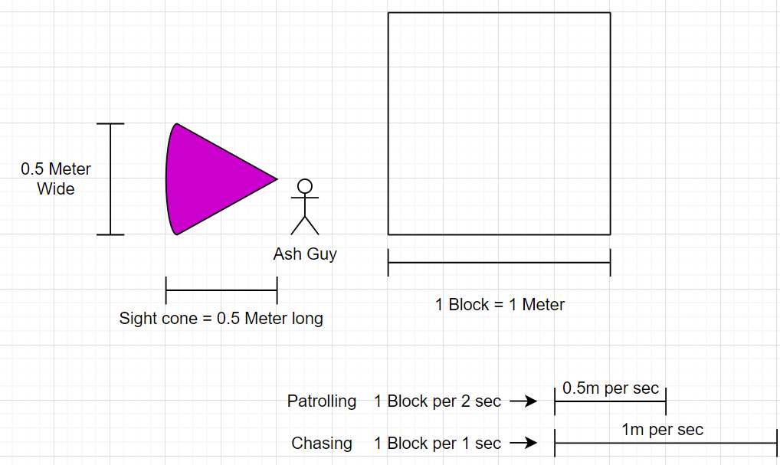

**Time to kill:** 2 seconds (if the player stays in the sight cone for longer, they die/lose) The player can stay in the cone for 2 seconds, at exactly 2 seconds the Ash enemy rolls towards him and kills the player

**Losing:** Once the enemy hits the player, the player loses

**Rotation speed:** rotate 90degrees in 2seconds while patrolling (this means that they slowly rotate to their next destination point)

If the enemy is chasing the player, the rotation is instant because the player can no longer escape

**Vision Cone:** 0,5 Block long, 0,5 Block wide and 45 degrees wide

## Backstory

There were once some very happy creatures running around a house, but one day, an evil fire consumed the house where they lived at. The fire started of small but started to inhale everything in their way, paper, toys, doors, wood…

Most of these happy creatures died in the fire, and the ones that remained, turned into ashes, they swore to protect the house from any other possible fire, making them angry and paranoid of everything and everyone.

## Flags